**Assignment 9**

**Data Science Masters**

**Read the dataset from the below link**

[**https://raw.githubusercontent.com/guipsamora/pandas_exercises/master/06_Stats/US_Baby_Names/US_Baby_Names_right.csv**](https://raw.githubusercontent.com/guipsamora/pandas_exercises/master/06_Stats/US_Baby_Names/US_Baby_Names_right.csv)

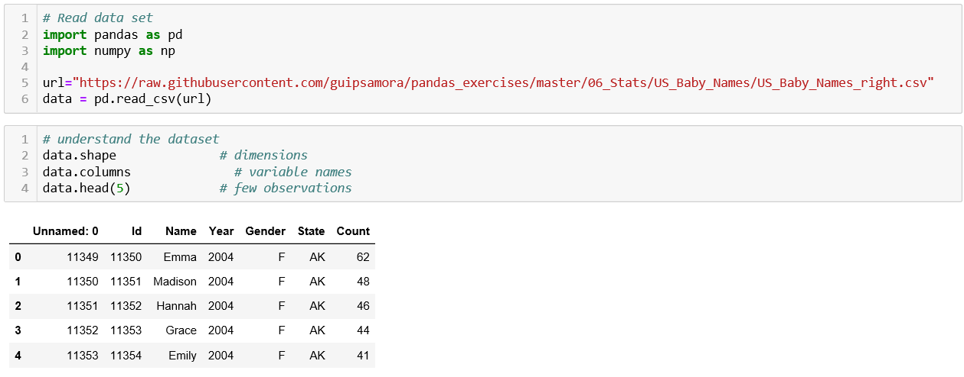

1. **Delete unnamed columns**

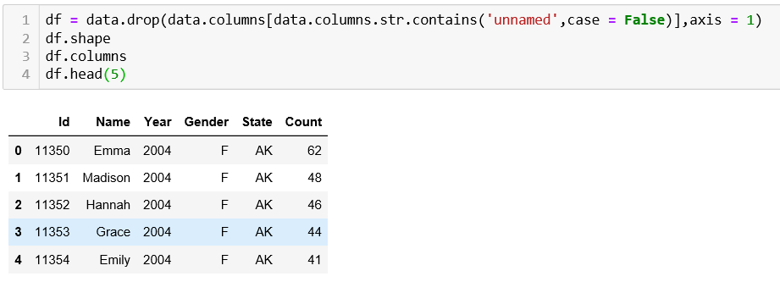

1. **Show the distribution of male and female**

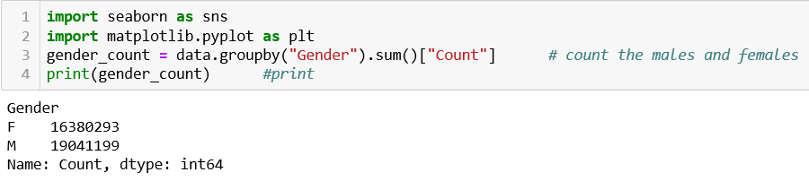

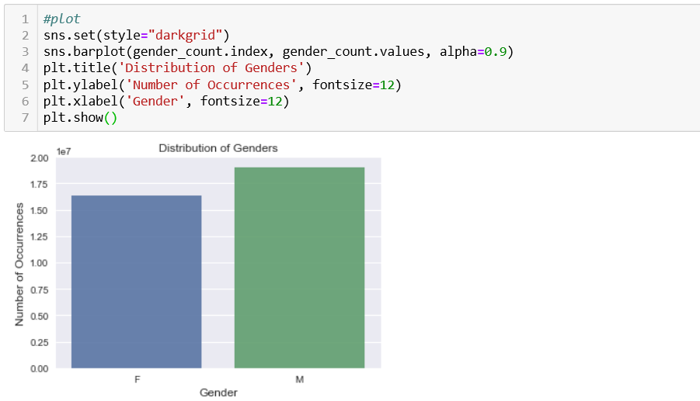

1. **Show the top 5 most preferred names**

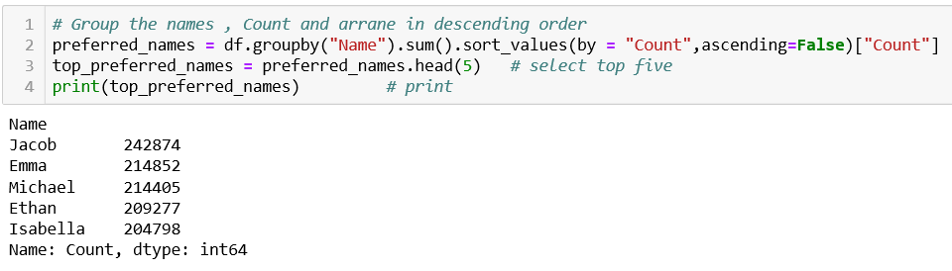

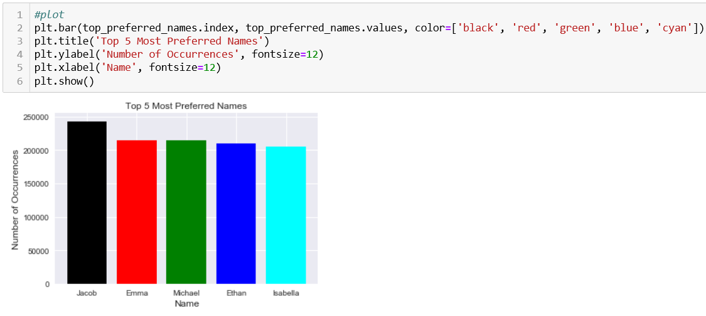

1. **What is the median name occurrence in the dataset**

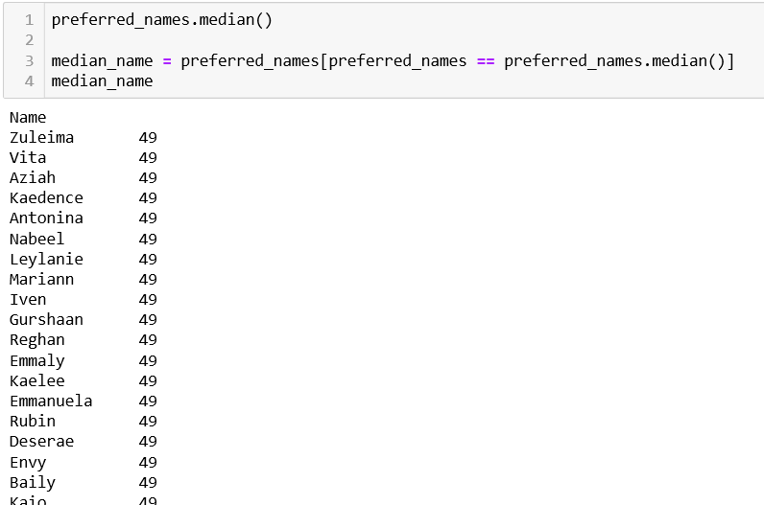

1. **Distribution of male and female born count by states**

